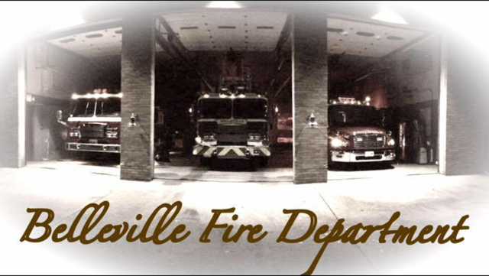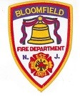Belleville & Bloomfield Fire Departments
Invite you to attend the following Seminar:
Lessons Learned From the Most Deadly Fires in History
Lectured by: Professor Glenn Corbett, John Jay College, NYC;
& Technical Editor, Fire Engineering Magazine
Hackensack, The Great Chicago Fire 1871, The San Francisco Earthquake & Fire 1906, Triangle Shirtwaist Factory 1911,Coconut Grove & Many Others….
In this class, the most important fires in American History are analyzed through a variety of lenses, including building construction, fire behavior, human behavior, along with strategy and tactics. Emphasis will be on distilling the lessons learned from each fire.
This class is perfect for everyone in the Fire Service from “The Probie to The Chief Officer”
There is no cost to attend and open to all Fire Departments
To Be Held on:
Monday February 27, 2017 10:00 AM-12:00
Bloomfield College
Van Fossan Theatre
449 Franklin Street
Bloomfield NJ
RSVP to B/C Marty Lutz Mlutz@bellevillefiredept.org
D/C Lou Venezia Lvenezia@bfpfcu.com

